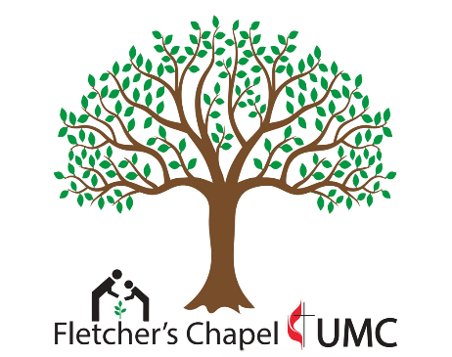
Fletchers Chapel United Methodist Church
Golf Tournament
Friday November 7, 2025
Tee Times: 10:00 AM
South Granville Country Club
Your participation in our golf tournament helps support the United Methodist Committee on Relief (UMCOR)- Western NC area. The deadline for entering the golf tournament will be October 31, 2025. The make-up date is November 20th, 2025. Please contact Brandon Lemons at blemons828@gmail.com with any questions or to sign up.
__Team Registration $400 __Champion Sponsor and Team: $450
Includes: green fees, cart, and lunch Includes: Hole sponsor sign and 1 Team
__Single Golfer $100 __Champion Sponsor: $100
(We’ll assign you to a team) Includes: Hole sponsor sign

__Bundle Packet- $25
2 Mulligans, 1 Tee Busters, and 2 Throws
(one bundle per person or 4 per team)

Make Checks Payable To: Fletcher’s Chapel United Methodist Church

Contact Information for Sponsorship:

Sponsor/Team Name: _______________________ Email: _________________________Phone:_______
Contact Information for Teams:

Name: _____________________________ Phone Number: ______________

Email: _____________________________

Name: _____________________________ Phone Number: ______________

Email: _____________________________

Name: _____________________________ Phone Number: ______________

Email: _____________________________

Name: _____________________________ Phone Number: ______________

Email: _____________________________

